 **Earlymathca.org Scavenger Hunt**

Go the website <http://www.earlymathca.org/> to find the answers.

1. What color is the 1st Grade bubble on the home page? _______________________________

[](http://www.earlymathca.org/math-exploration-kit)

1. Circle the logo that is on the Parents page?
2. On the Educator page, what is the age group that the resource “Texas School Ready” is geared towards? ________________________
3. On the Growth Mindset Six Reasons page, which reason is the color blue? __________________
4. List 3 book titles that are in the Growth Mindset category. _____________________________, _________________________________, ___________________________________
5. Under the Learning Progression tab, select 2nd Grade then answer this question. How many critical areas of Instruction are listed? ______________
6. Under the Learning Progression tab, select TK. Read the page and write the missing word in the sentence below.

TK is, therefore, **a___________________ between** preschool and the kindergarten year.

1. List 2 book titles that are in the Math Books category and that have the name of a shape in the title. ____________________________________, ____________________________________
2. Under the Stuff To Do tab, select Printables then write how many printables are listed. _______
3. Under the Stuff To Do tab, select Music Lyrics then write the name of the song listed below each picture.

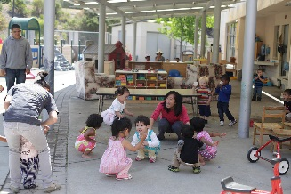

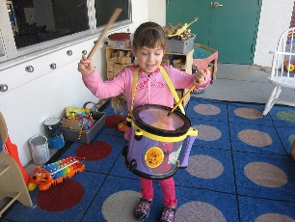

__________________ ____________________ ____________________

Thank you for exploring the website!